Ars Magna Dna Kop Jes

By Tristan Reed

Harry Potter anagrams:

1. Try part hero
2. Yellow and ears
3. Save pureness
4. Go Sir Dumbledore
5. Of a cold army
6. The garlicky drool
7. We salute harry
8. Will ably see
9. So moral today
10. Nervously nerd
11. I a clumsy foul
12. Death moans

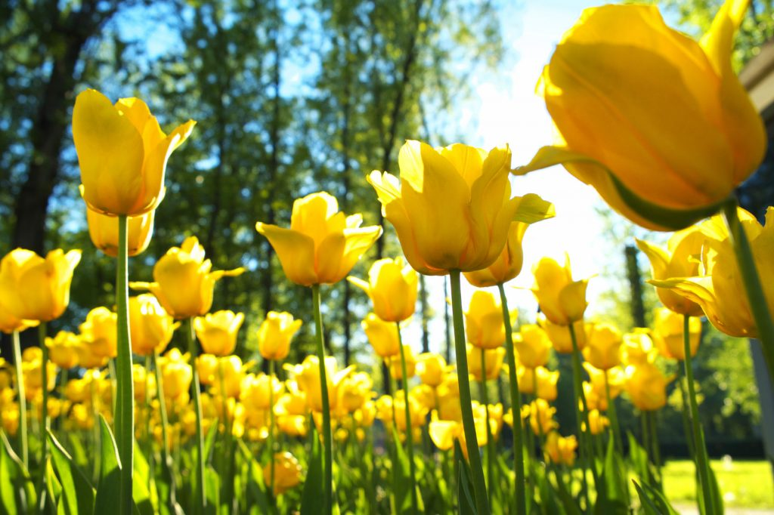Spring anagrams:

1. Es de
2. Wolfer
3. Eder
4. Puc, tubter
5. Blam!
6. Ebe

Adjectives anagrams:

1. Do Hiri
2. Gib
3. H.M.Y git
4. Ar gel
5. Nufny
6. Carsy
7. Gerat
8. Loco
9. C.R.ZAY
10. Tup,sid

Song anagrams:



1. Camy
2. does it pac
3. Tel bite
4. Peep,moc,moon, L
5. da la viviva
6. Ye H.jude
7. Dense foil shelnut
8. Cool mud get FFY
9. Laney penn
10. Huts very obeyd

**JOKES**

Harry Potter jokes:

Where does Professor Quirrell shop?

Turban outfitters!

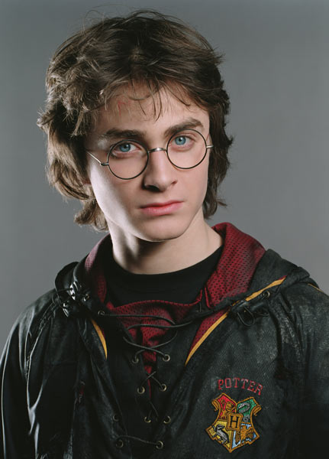What do you call a Headmaster of Hogwarts who does not speak clearly?

Mumbledore!

What do you call a Headmaster of Hogwarts who keeps tripping on his cloak?

Stumbledore!

What do you call a Hogwarts teacher with a bad attitude?

Moody!

Genius jokes:

What is the fastest way to count cows?

Use a cowculator!

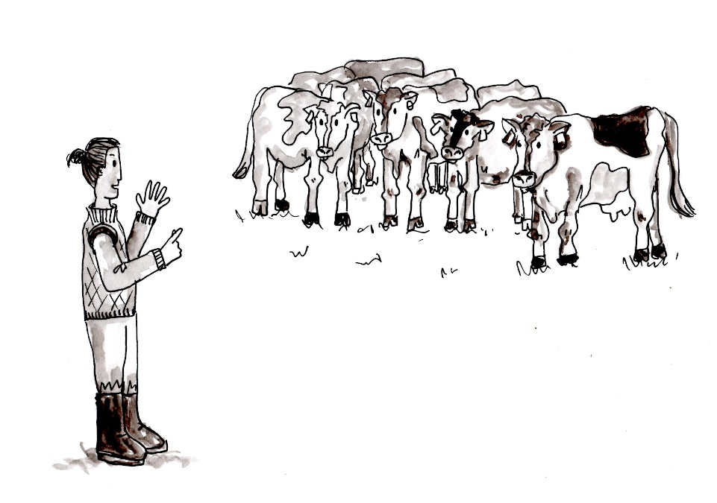

Why are adults always moaning?

Because they are groan ups!